IELTS Writing Achieve 6.5 (sample videos)

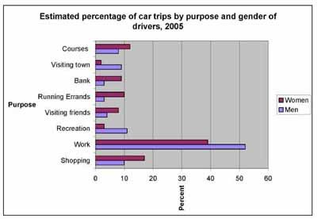
IELTS Writing Achieve 6.5 (sample videos)
Format / Quality: MP4

Example 1 Bar Chart, Line Graph
Example 2 Bar Chart and Pie Chart
Example 3 Describing a table
Example 4 Describing a pie chart
Example 5 Describing a line graph
Example 6 Describing a bar chart
Example 7 Good Essay, Bad Essay
Lesson1 Describing Trends
Lesson2 Variables and Time
Lesson3 Statistical Data
Lesson4 Participle, Relative Clauses
IELTS Writing Practice Videos

